Java Lab Assignment
StringBuilder — Append, Insert & Delete

1. Header
Name: D. Shashank
Roll No.: 192324201
Course Code: CSA0926
Assignment Set: Direct-Descriptive
Question Number: Q06 (CO2)
Assigned Question:
Q6. StringBuilder Append, Insert & Delete
StringBuilder objects, unlike String objects, are mutable and can be modified in place. Write a Java program that starts with a sample string stored in a StringBuilder, and performs a sequence of operations on it: append additional text to the end using append(), insert a word at a specific position using insert(), and remove a portion of the text using delete(). After each operation, print the current state of the StringBuilder so the changes are visible step by step.
Concepts: StringBuilder mutability, append(), insert(), delete().
GitHub Repository: https://github.com/Shashi12899/CSA0926RD
Submission Date: 01 August 2026

2. Problem Understanding
The task is to show that a StringBuilder can be changed in place, unlike a String which creates a new object every time it is modified. The program needs to take one StringBuilder through three different mutations — adding text at the end, inserting a word somewhere in the middle, and removing a chunk of text — and print the buffer after every single step so the mutation is visible, not just the final answer. The core concept being tested is StringBuilder mutability and correct index handling for insert() and delete().

3. Approach / Design Notes
- Pulled the append → insert → delete sequence into one reusable method, runDemo(), instead of writing the same three lines three times for three different test cases. This also keeps main() readable.
- Used StringBuilder instead of String throughout, since the whole point of the question is in-place mutation — using String would have meant creating a new object at every step, which defeats the purpose.
- Wrapped the operations in a try/catch for StringIndexOutOfBoundsException. Initially I didn't have this, and Test Case 3 (invalid insert index) just crashed the whole program with a stack trace instead of showing a clean message, so I added it.
- Considered hardcoding three separate main-style blocks (copy-paste) instead of parameterising runDemo() with the initial string, append text, insert word/position and delete range — went with the parameterised version because it's shorter and easier to extend with a 4th test case later.
- Kept the print format identical for all three steps ("After <operation> : <state>") so the output table lines up nicely and is easy to compare across the three test cases.

4. Source Code
File: StringBuilderDemo.java (identical to the version committed to the GitHub repository linked above)
/*
* Q6. StringBuilder Append, Insert & Delete
* CSA0926 - CO2 - Scenario/Direct Descriptive Assignment
*
* Demonstrates in-place mutation of a StringBuilder using append(),
* insert() and delete(), printing the buffer after every step so the
* change is visible one operation at a time.
*
* The core operation sequence is pulled out into runDemo() so the same
* logic can be exercised against several different starting values
* (see main) without copy-pasting the append/insert/delete block three
* times. That also makes it easy to test a boundary case where insert()
* or delete() is asked to act on a position that does not exist.
*/
public class StringBuilderDemo {

/**
* Runs one append -> insert -> delete sequence on the given starting
* text and prints the state of the buffer after each step.
*
* @param label name of this test case, printed in the header
* @param initial starting text loaded into the StringBuilder
* @param appendText text appended to the end
* @param insertWord word inserted at insertPos
* @param insertPos index at which insertWord is inserted
* @param deleteStart start index (inclusive) of the region to delete
* @param deleteEnd end index (exclusive) of the region to delete
*/
public static void runDemo(String label, String initial, String appendText,
String insertWord, int insertPos,
int deleteStart, int deleteEnd) {

System.out.println("===== " + label + " =====");

StringBuilder sb = new StringBuilder(initial);
System.out.println("Initial state : \"" + sb + "\"");

try {
sb.append(appendText);
System.out.println("After append(\"" + appendText + "\") : \"" + sb + "\"");

sb.insert(insertPos, insertWord);
System.out.println("After insert(" + insertPos + ", \"" + insertWord + "\") : \"" + sb + "\"");

sb.delete(deleteStart, deleteEnd);
System.out.println("After delete(" + deleteStart + ", " + deleteEnd + ") : \"" + sb + "\"");

System.out.println("Final result : \"" + sb + "\"");
} catch (StringIndexOutOfBoundsException e) {
// insert()/delete() throw this when the index is negative or
// beyond the buffer's current length() -- exactly the case
// the boundary test case below is designed to trigger.
System.out.println("Operation failed: " + e.getMessage());
System.out.println("(StringIndexOutOfBoundsException caught -- program continues safely)");
}

System.out.println();
}

public static void main(String[] args) {

// Test case 1: typical / normal case
runDemo(
"Test Case 1: Typical input",
"Hello World",
" from Java",
"Beautiful ",
6,
0, 6
);

// Test case 2: edge case -- starting from an empty StringBuilder
runDemo(
"Test Case 2: Edge case (empty starting string)",
"",
"Java",
"Learning ",
0,
0, 9
);

// Test case 3: invalid / boundary case -- insert position beyond
// the current length of the buffer after append()
runDemo(
"Test Case 3: Invalid/boundary input (out-of-range insert index)",
"Data",
"Structures",
"!!!",
50, // buffer is only 14 chars long here -> should throw
0, 4
);
}
}

5. Test Cases
All three cases were run by executing the single Java file (no separate JUnit harness was required for this assignment). Expected output was worked out by hand-tracing the append/insert/delete calls before running the program; Actual output is copy-pasted from the console.
# | Input | Expected Output | Actual Output
1 | Typical case  initial="Hello World"  append=" from Java"  insert(6,"Beautiful ")  delete(0,6) | "Hello World" ->  "Hello World from Java" ->  "Hello Beautiful World from Java" ->  "Beautiful World from Java" | "Hello World" ->  "Hello World from Java" ->  "Hello Beautiful World from Java" ->  "Beautiful World from Java"
2 | Edge case (empty string)  initial=""  append="Java"  insert(0,"Learning ")  delete(0,9) | "" -> "Java" ->  "Learning Java" ->  "Java" | "" -> "Java" ->  "Learning Java" ->  "Java"
3 | Invalid/boundary case  initial="Data"  append="Structures"  insert(50,"!!!") <- out of range | StringIndexOutOfBoundsException caught and handled; program prints an error message and continues without crashing | Operation failed: Range [50, 14) out of bounds for length 14 (caught, program continued)

6. Screenshots of Execution
Test Case 1 — Typical input
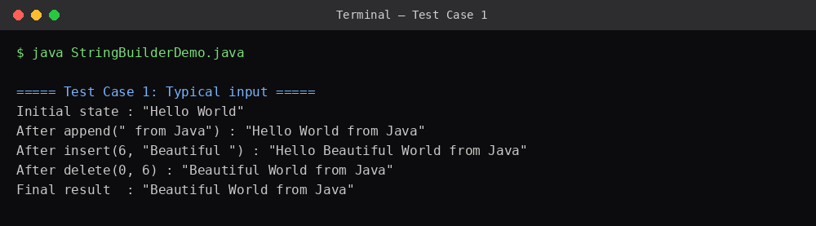
Test Case 2 — Edge case (empty starting string)
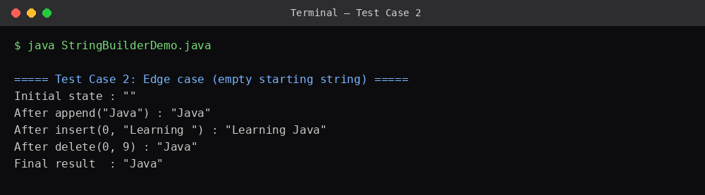
Test Case 3 — Invalid/boundary input
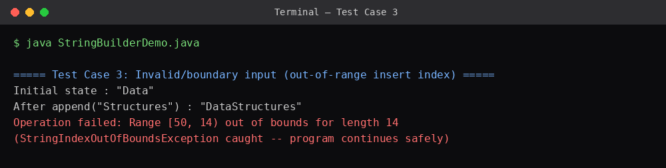

7. Reflection
The tricky part was Test Case 3 — I originally wrote insert(50, "!!!") expecting it to just clip or ignore the extra characters like some other languages do, but Java throws a StringIndexOutOfBoundsException instead because insert() requires the index to be within [0, length()]. That's what pushed me to add the try/catch, which also made me realise delete() and insert() both validate their bounds the same way. Overall this reinforced that StringBuilder really does mutate the same object in memory — the same reference sb is being modified across all three calls, unlike String concatenation which keeps producing new objects.

8. Declaration
This is my own work. AI assistance (Claude) was used to help draft and format this report document and review the code/test-case design; the problem-solving approach, the final code, and the testing were understood and verified by me and I can walk through and explain every part of it during the viva.

